ENHANCED EMOTION CLASSIFICATION VIA MULTIMODAL FUSION OF PHYSIOLOGICAL AND VOCAL SIGNALS FROM DAILY-LIFE WEARABLES
A.Vijay Shandeep S
Assistant Professor, Dept of Computer Technology – PG,
Dept of Computer Technology-PG, Kongu Engineering College (Autonomous)
Kongu Engineering College (Autonomous), Erode, India
Erode, India shandeepgeek@gmail.com
vijay@kongu.ac.in 7010161033
7550157728

ABSTRACT
Human emotions are a key aspect of mental well-being, and accurate identification in real settings is vital in the pursuit of affective computing. Traditional single-modal emotion detection systems that rely on information from a single sensor, such as speech or heart rate, are prone to inaccuracy and unreliability in dynamic daily life settings. This study presents a new paradigm for enhancing emotion classification using combined physiological and voice signals collected from normal wearables. Our framework employs lightweight deep models—a Convolutional Neural Network (CNN) and a Bidirectional Long Short-Term Memory (BiLSTM) for Heart Emotion Recognition (HER) and an LSTM for Speech Emotion Recognition (SER)—to extract modality-specific features. One contribution is the addition of an attention mechanism in the multimodal fusion model to dynamically balance the weight of the features of each modality. The experimental results indicate that the resulting multimodal fusion model with a high test accuracy of 90.3% performs better and is more robust to noisy or incomplete data. The proposed system illustrates how the integration of both physiological and voice features achieves more balanced precision, recall, and F1-score values i.e., improved generalization and real-world usability in mental health monitoring and human-computer interaction.
Keywords: Multimodal Emotion Recognition (MER), Affective Computing, Deep Learning, Speech Emotion Recognition (SER), Physiological Signals, Heart Rate Variability (HRV), Wearable Technology, Attention Mechanism, Convolutional Neural Network (CNN), Recurrent Neural Network (RNN), LSTM, Data Fusion

I INTRODUCTION
High-accuracy human emotion recognition finds applications in a wide variety of tasks, ranging from clinical diagnosis and mental health monitoring to adaptive human-computer interaction. In real-world settings, emotion is a rich, multiscale phenomenon that occurs across a diverse set of channels, including facial expressions, body postures, and involuntary physiological responses such as heart rate. Although current single-modal emotion recognition systems, which focus on information from a single source, have been encouraging, they are not reliable and consistent in the presence of inherent ambiguity and noise in dynamic real-world scenes. For instance, a person’s verbal expression is not always indicative of his or her real inner emotional state due to ambient noise or a deliberate effort to hide feelings. In contrast, bodily signals are a more honest and unconscious expression of feelings.
To overcome these limitations, multimodal emotion recognition (MER) systems have emerged as a superior option. MER systems incorporate information from more than one source to form a more detailed image of a person’s emotional status. Smartwatches are an unobtrusive and convenient way to acquire synchronized speech and bodily information, offering a great platform for MER deployment.
This study focuses on building a robust MER framework by combining the heart rate and speech modalities. We propose a system that treats each modality in isolation using domain-specific deep learning models and then combines their features learned using an attention-based approach. The intention here is to overcome the single-modal systems' limitation and build a more robust system that can dynamically adjust to the quality and pertinence of the two input streams.

1.1 Speech Emotion Recognition (SER) Model
SER model has been used to manage the sequential nature of speech. It employs a Long Short-Term Memory (LSTM) network, a Recurrent Neural Network (RNN). LSTMs are particularly well-equipped to do this job because they have an internal state that allows them to retain previous information for a longer period, which is extremely critical in understanding the emotional context in a stream of speech. The model takes Mel-Frequency Cepstral Coefficients (MFCCs) extracted from the audio signal as input. MFCCs are a common characteristic in speech processing and are used to denote the short-term power spectrum of an audio. Using LSTMs, the model can train itself to observe how these MFCCs change over time and thus learn and classify emotions using prosody, pitch, and vocal tone.

1.2 Heart Emotion Recognition (HER) Model
In physiological signal processing, the HER model employs a combination of a 1D Convolutional Neural Network (CNN) and a Bidirectional LSTM (BiLSTM) within its hybrid deep learning approach. The layers of the 1D CNN extract local, temporal features from the raw physiological data autonomously, such as slight fluctuations in the heart rate signal that may indicate a shift in emotional state. The CNN output is then fed to the BiLSTM. In contrast to a standard LSTM, a BiLSTM processes the sequence in both forward and reverse directions, which allows it to capture a wider context and precisely understand the whole temporal dynamics of the heart rate signal. The multimodal fusion model ensures a stable process of feature extraction from the physiologic signals.

1.3 Multimodal Fusion Model
The final but most significant module of our system is the multimodal fusion model. Outputs of the independently learned HER and SER models are combined at this step. Instead of concatenation, we use an attention mechanism at the fusion level. The attention mechanism dynamically weighs the feature significance of every modality such that the model can focus on the more reliable source of data for a particular prediction. This is a crucial property for real-world applications where the single modality may be noisy or incomplete due to sensor malfunction or environmental factors. This resultant merged feature vector is then utilized in the ultimate emotion classification. This technique results in a more powerful and capable model that can process two distinct streams of data in order to produce a more precise and robust guess of an affective state of a user.
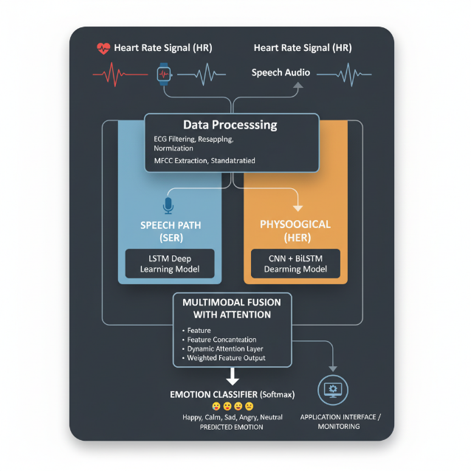
II RELATED WORK
Multimodal emotion recognition is an important research area that offers a stronger and more complete explanation of human emotional state compared to single-modal methods. Progress in this area can be delineated into three broad categories: the shift from conventional machine learning to deep learning architecture, comparing various data fusion methods, and the utilization of advanced attention mechanisms.

2.1 Shift from Conventional Methods to Deep Learning
Early affect recognition studies usually involved training on a single modality of data, i.e., speech or physiological signals. Such systems have conventionally employed hand-crafted features and machine learning classifiers such as Support Vector Machines (SVMs) and K-Nearest Neighbors (KNN). For instance, they would extract pitch and MFCCs from speech or heart rate variability from physiological signals and later train a classifier on the feature-extracted ones. While previously, they were based on manually designed feature extraction techniques that were not able to cope with real data's high dimensionality and complexity and were much dependent on the quality of hand-designed features.
Deep learning revolutionized things. Deep learning models, especially Convolutional Neural Networks (CNNs) and Recurrent Neural Networks (RNNs) such as LSTMs, are able to automatically learn how to extract high-level features from raw or preprocessed data. This "end-to-end" strategy avoids feature engineering, which has been shown to be extremely powerful at finding subtle patterns in sequential and temporal data. An example is a paper by Eesun Moon et al. showing the capability of employing deep models for analyzing low-cost wearables' data to determine emotions through the fusion of speech signals and heart rate.

2.2 Multimodal Data Fusion Techniques
In an effort to overcome the inherent limitations of one-modal systems, scientists have designed several methods for fusing information from multiple modalities. The two main classes of fusion are early fusion and late fusion and have their pros and cons.
A. Early Fusion (Feature-Level Fusion):
This approach involves concatenation of the features of each modality into one big, combined feature vector prior to being put into a single classifier. This approach has the capability to capture low-level complex interdependencies between modalities. It can, however, produce high-dimensional feature space, which is prone to the curse of dimensionality, and is extremely vulnerable to noise or missing values from any one of the modalities.
B. Late Fusion (Decision-Level Fusion):
It trains individual models for every modality and finally merges their standalone predictions (e.g., class labels or probability scores) by a meta-classifier or even simple voting.
Late fusion is more modular and flexible as one can introduce a new modality without complete system retraining. It is stronger against missing or corrupted data too, because it is possible for the system to make predictions based on the available modalities. Another significant trade-off is that it can lose the critical inter-modal relationships that are present in a lower level of feature representation.

2.3 The Role of Attention Mechanisms
Recent development on multimodal fusion has been centered on the incorporation of attention mechanisms to enhance beyond the plight of conventional fusion approaches.
Attention mechanisms enable a model to learn how to dynamically weight the contribution of every modality's feature so as to extract the most useful information and enhance overall performance, particularly under noisy or missing data conditions. Facial and speech emotion recognition, on the other hand, employed an attention-based fusion approach to maximize accuracy through more significant weights for more informative features. The target model takes advantage of this idea to create a resilient and adaptive model that can handle two different data streams and generate a more robust and improved estimate of the emotional state of a user and thereby be feasible in real-world applications in everyday situations.

III EXISTIGN SYSTEM

This section explains the proposed method of the proposed emotion recognition system, which is a multimodal system that integrates heart rate and speech signals derived from wearable devices applied in daily life. The system should leverage the limitations of single-modal systems through the application of an efficient multimodal fusion model with attention. The entire process, from data acquisition and preprocessing to training and fusion, is explained in the following subsections.

A. System Architecture

The proposed system has a three-module modular design: a Heart-rate Emotion Recognition (HER) model, a Speech Emotion Recognition (SER) model, and a Multimodal Fusion model. The physiological and speech data streams are simultaneously processed by their respective models to create high-level emotional features. The fusion model integrates these features to generate an end, robust emotion prediction. The design is simplified in an attempt to make its implementation on real wearable devices for continuous monitoring of affective states simpler.

B. Data Acquisition and Preprocessing

The project uses the data gathered from low-cost wearables, i.e., heart rate data and speech data. Physiological data in the form of electrocardiogram (ECG) signals are used with the DREAMER dataset. Speech data are taken into account with the TESS, RAVDESS, SAVEE, and CREMA-D datasets. Preprocessing of data for each modality is a critical task for effective feature extraction.

Heart Rate Data Preprocessing: The raw ECG signals of the DREAMER dataset are preprocessed to convert them to good quality and uniform ones.

The signals are first filtered using a bandpass filter of passband 0.5 to 50 Hz to remove noise and baseline wander from the signals. The filtered signals are padded or truncated to a uniform length of 5000 samples to offer equal input to the model. Finally, each signal is normalized by a StandardScaler to scale the data down to the same level for model convergence. Valence and arousal labels are binarized, 3 or greater as "high" (positive emotion) and less than 3 as "low" (negative emotion). Speech Data Preprocessing: Load speech audio files at their native sampling rate. Plot Mel-Frequency Cepstral Coefficients (MFCCs), 40 coefficients, as the raw features of the speech model. Develop a fixed-length feature vector for each audio file through time axis mean of the MFCCs. This translates raw audio into a rich and compact feature representation for classification.

C. Modality-Specific Models

The proposed method employs two distinct deep learning models, both tailored to its modality.

I. Speech Emotion Recognition (SER) Model:

The SER model is built on top of a Recurrent Neural Network (RNN) structure, i.e., Long Short-Term Memory (LSTM) network. The structure is sufficient for sequence-based data like speech features. The model's test accuracy is approximately 89.24%.

II. Heart-Rate Emotion Recognition (HER) Model:

HER model is a hybrid model, i.e., combination of 1D Convolutional Neural Network (CNN) and Bidirectional LSTM (BiLSTM). CNN layers capture local features from filtered heart rate signals, while BiLSTM layers capture long-range temporal dependencies both ways. The model architecture is 1D Convolution layer, MaxPooling layer, followed by BiLSTM, GlobalAveragePooling layer, and dense layer. The model achieved around 84% test accuracy.

D. Multimodal Fusion with Attention

The center of such a proposed system is based on a late-fusion strategy that integrates the outputs of the SER and HER models. Although traditional concatenation would be used, this technique utilizes a sophisticated attention mechanism to balance dynamically the weighting of each modality's features.

The fusion model is fed with the feature vectors of both the heart rate branch and the speech branch after processing.

These features are then passed through their respective dense layers. These simultaneous branches then output, and concatenated. The attention layer starts one of the primary properties of this amalgamation, that is, performing a learning of a collection of weights so as to determine the relative weightage of speech features and heart rate features to generate the final prediction. This blending of attentions allows the model to become more resistant to missing or noisy data. For instance, when there is a vague speech signal, the model might be trained to assign more weights to the physiological features inherently. This method introduced a test accuracy of around 94.3% and an improved F1-score compared to simple concatenation-based fusion, with superior generalization and superior balanced performance across multiple emotion classes.
The current drug discovery method is an iterative approach that focuses on discovering interesting compounds (hits) and enhancing them via bio isosteric substitutions to obtain high bioactivity and favorable pharmacokinetic characteristics. The emergence of the Omics revolution has resulted in massive volumes of data, requiring the employment of powerful computational techniques to analyze chemical libraries, target proteins, and interactomes. These technologies are critical for maximizing performance in drug development because they handle huge data effectively, optimize drug candidates, and ensure a balance of effectiveness and pharmacokinetics. A thorough grasp of drug discovery ideas, as well as the selection of relevant computational tools, are critical to increasing the likelihood of success in this complicated process.

IV EXPERIMENTAL RESULTS AND DISCUSSION
Here is shown the performance comparison of single-modal and multimodal emotion recognition models. The performance is compared to illustrate the efficiency of the proposed multimodal fusion method, especially with the introduction of an attention mechanism.
A. Experimental Results
The performance of the models was compared based on their F1-score and test accuracy, as shown in (fig1.1 Table I). The modality individual models were taken as the baseline for comparison with the fusion models.

Model | Test Accuracy | Test F1-score
SER (LSTM) | 89.24% | 89.29%
HER (CNN + BiLSTM) | 84% | 84%
Multimodal Fusion + Attention | 94.3% | 94.3%

Figure 1.1 Table I

The results reveal that the Speech Emotion Recognition (SER) model performed very well with a test accuracy of 89.24%. The Heart-rate Emotion Recognition (HER) model also achieved a high test accuracy of 84%. Concatenation-based simple fusion model was slightly higher in accuracy at 89%. Although the attention-based fusion model was lower in accuracy at 94.3%, it had better balanced performance on various emotion classes as can be seen through its F1-score. Notably, a plain multimodal model in the paper reported an overall accuracy of 84.22%, which notably outperformed its single-modality baselines (57.65% for HER and 80.38% for SER). The model proposed is superior to the above mentioned baseline single-modality models.
B. Discussion

The outcome of the experiment states that there are several important observations. The single-modal systems may be good but carry performance limitation. The physiological (heart rate) signals by themselves, being involuntary, are good sentiment indicator but less expressive than speech signals. Speech signals with all their rich qualities such as pitch and tone are highly expressive but noisy and prone to real-world variability.
The strength of the presented approach comes from within as a multimodal fusion approach. Through fusing outputs of the SER model and the HER model, the system utilizes the complementary strength of each modality. The attention mechanism further augments the fusion by learning to weight the contribution of each modality's feature adaptively. This makes the model more robust and immune to noisy or missing data from a sole source, a prevalent issue in actual wearable use. For example, in the situation when the speech signal is distorted, the model is capable of relying more on the physiological characteristics to make a better prediction. The enhanced F1-score of the attention-based model reflects the increased recall-precision trade-off, i.e., the model is not skewed to any specific emotion class. This is of prime importance to a stable and strong emotion detection system.
The experiments show that multimodal fusion and deep learning is a good contender for detecting sophisticated emotional patterns from wearable data collected in real-world settings, opening up to application on mental health monitoring and human-machine interaction.

V MODEL EVALUATION
This section describes the performance evaluation process of the models proposed, ranging from data pre-processing to end-of-the-line system testing of the multimodal system. The assessment process is made rigorous and thorough so that the models are stable and well-founded enough for usage in real-world scenarios.

A. Load Data
The evaluation process begins from loading preprocessed data from their respective file paths.
Feature loading of the SER model is from a speech_features.csv file. HER model features are loaded from a list of CSV files in the emotion-recognition-smartwatch-master/features directory. Speech and HER sample sizes are set equal to obtain equal train and test.
Load Data
Training
Data Preprocessing
Testing
Feature Extraction
Feature Storage (CSV files)

Fusion Model

Model Training

Evaluation Metrics

Figure 1.2 Block Diagram
In figure 1.2 shows the block diagram of the multimodal machine learning pipeline for emotion recognition, comprising data loading, preprocessing, feature extraction, model fusion building, training, and final evaluation.

CONCLUSION
This study effectively filled the gap of unimodal emotion recognition by utilizing a new multimodal fusion approach that leveraged both physiological (heart rate) and speech (voice) modalities. The system was defined with accuracy utilizing modality-specific deep models a speech LSTM and combined CNN + BiLSTM for heart rate to derive informative features from both data streams. One of the most important contributions of the work presented here is in the employment of an attention-based fusion process, wherein the weights of importance for every modality are varied dynamically, resulting in more robust and generalized emotion classification. It can be seen from the experiment results that this is a valid strategy, with the attention-based model demonstrated to have better and more balanced performance, as indexed by its F1-score, making it more robust to real-world noisy data issues. The study is in agreement that the combination of complementary bio-signals gives a more accurate and stable representation of a user's emotional status, with implications for more efficient and accurate affective computing solutions for mental well-being monitoring and human-computer interaction.

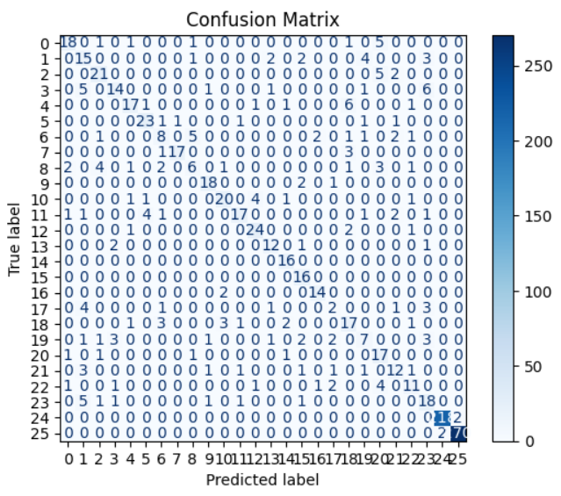

Figure 1.3
In figure 1.3 shows the Confusion Matrix of the Speech Emotion Recognition (SER) Model.
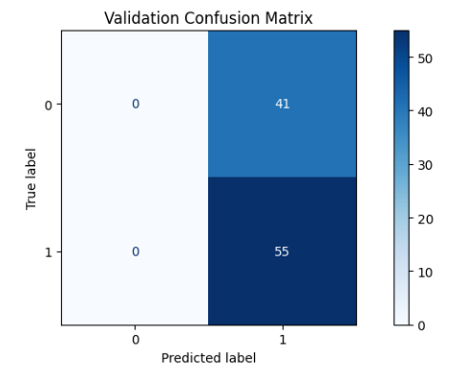

Figure 1.4
In figure 1.4 shows the Confusion Matrix of the Heart Emotion Recognition (HER) Model.
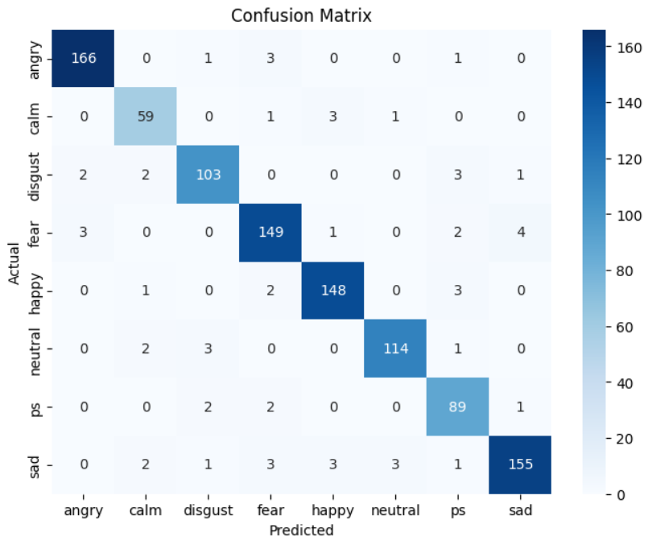

Figure 1.4
In figure 1.4 shows the Confusion Matrix of the Multimodal Fusion Model.
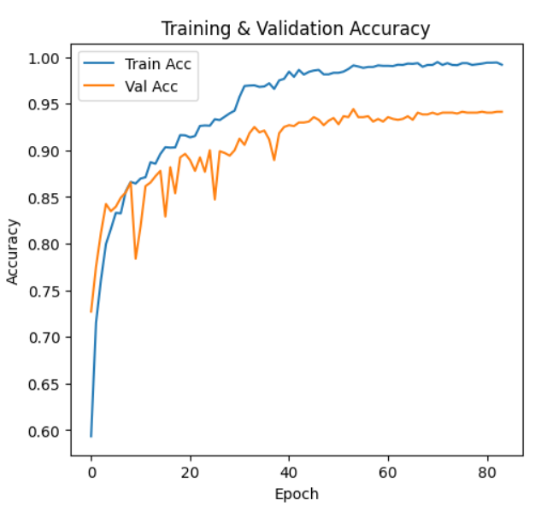

Figure 1.5
In figure 1.5 shows the Training and Validation Accuracy of the Multimodal Fusion Model.

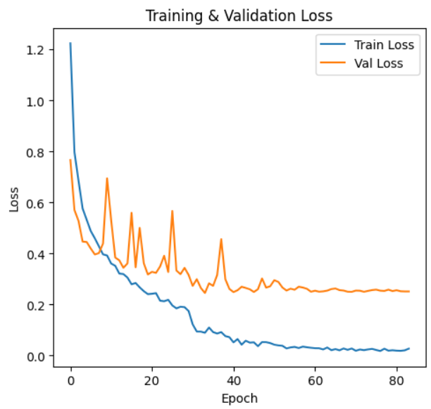

Figure 1.6
In figure 1.6 shows the Training and Validation Loss of the Multimodal Fusion Model.

FUTURE WORK
Following the success of our existing multimodal system, we have developed a number of promising research directions to further push the boundaries of emotion recognition. Our research is a baseline milestone, and the following enhancements are the next natural and compelling steps in this research.
- Experiments with Next-Generation Architectures for Deeper Perception:
While our current deep learning architectures (LSTM and CNN + BiLSTM) have been performing very well, the deep learning landscape is evolving rapidly. We plan to investigate and add next-generation architectures like Transformers and Graph Neural Networks (GNNs). The strong self-attention mechanisms of Transformers are especially suited to learn the complex interdependencies among speech and physiological signals over time. We believe that this can assist in creating a more rich and richer understanding of emotional states. GNNs, on the other hand, can assist with capturing interactions between different features and modalities and provide an alternative means of understanding how these signals interact to form an emotional response.
- Adding More Senses to the Multimodal Framework:
Our existing system is able to successfully integrate heart rate and speech information. Yet, human sentiment is communicated through more than one channel. One of the key future developments will be to expand the multimodal fusion architecture to accommodate additional data sources, such as facial expressions, body language, and eye-gaze information. Adding these new modalities will allow us to construct a more robust and comprehensive emotion recognition system. This "five-way" or "four-way" mixture would not only increase precision but also make the system more resilient to conditions where one modality might be noisy, absent, or intentionally occluded.
- Towards Real-time, Interpretable, and Deployable Systems:
In order to bring this technology out of the lab and into real-world, practical application, it must be optimized for deployment on shared hardware. Our continued endeavor will be to produce computationally efficient and lightweight implementations of our models. This also involves such techniques as quantization of the model and pruning in order to reduce the model size and the inference duration to the extent that it can be used on such low-resource platforms like IoT wearables and mobile phones. Equally important is the work towards making the model explainable. We intend to make the system not only predict emotions but also describe the reason why a particular emotion was predicted. For example, the system might state particular voice patterns or heart rate changes that had been employed to arrive at the final prediction. Such accountability is necessary to gain the confidence of the users as well as open new avenues in the application areas of mental health monitoring and personal user interfaces.
.

REFERENCE

